Securely Communicating Over an IPv6 Network

Zeina Abdel Samad
School of Applied Technology
Illinois Institute of Technology
201 East Loop Road
Wheaton, IL 60189
(312) 833-4701
zabdelsa@hawk.iit.edu

Olivia Minton
School of Applied Technology
Illinois Institute of Technology
201 East Loop Road
Wheaton, IL 60189
(773) 747-0613
jcallana@hawk.iit.edu
Bartlomiej Dworak
School of Applied Technology
Illinois Institute of Technology
201 East Loop Road
Wheaton, IL 60189
(708) 299-1171
bdworak@hawk.iit.edu

Douglas Wilhelm
School of Applied Technology
Illinois Institute of Technology
201 East Loop Road
Wheaton, IL 60189
(269) 588-0595
dwilhel1@hawk.iit.edu

ABSTRACT
In our paper we look at the implementation of secure network communication utilizing the IPv6 Internet protocol. The Internet has been around since the early 1980s, and in that time has been operating on a protocol referred to as Internet Protocol version 4, often shortened to IPv4. While this protocol is the foundation of communication through the Internet, it has many vulnerabilities and security flaws, and its address space is too limited for continued use. A newer version of the protocol was released, IPv6, which expands on the original IPv4 implementation and other security features. In this project we create a network operating purely on the IPv6 protocol and communicating securely between hosts using IPsec authentication and encryption. We will verify the security of the protocol by viewing HTTP, PING, and SSH packet payloads through the Wireshark networking application. Packet analysis will occur on an Ethernet-enabled laptop added to the network which will passively intercept the communications.

Categories and Subject Descriptors
C.2.2 [Network Protocols]:
Protocol architecture (OSI model), Protocol Verification
General Terms
Experimentation and Security.
Keywords
IPv6, Ubuntu, IPsec, Networking, Servers, Security.
Permission to make digital or hard copies of all or part of this work for personal or classroom use is granted without fee provided that copies are not made or distributed for profit or commercial advantage and that copies bear this notice and the full citation on the first page. To copy otherwise, or republish, to post on servers or to redistribute to lists, requires prior specific permission and/or a fee.

INTRODUCTION
Although current commercial networking hardware supports IPv6, networks are often still configured using IPv4, which has slowed widespread adoption of the new standard. The reason behind the slow widespread adoption of the IPv6 protocol is the heavy reliance on the global IPv4 network currently in place. IPv4 also had a major security design flaw when it was conceived, as the protocol did not incorporate any way for two hosts to communicate securely over the Internet. This security flaw is addressed and subsequently solved by using IPsec, a protocol for secure communication, which is included in the IPv6 documentation. The problem our project hopes to address is how an organization can communicate securely at level 3 (L3) in the protocol stack using only IPv6 and IPsec.

PROPOSED SOLUTION
Our proposed solution involves several major components. We will be using a level three (L3) network router configured to use only IPv6 for packet transmission. This router will therefore direct network traffic based upon IPv6 addressing (L3), rather than directing network traffic using specific hardware MAC addresses (L2). The network hosts will be configured to utilize the IPsec authentication and encryption to create a small, secure network. While IPsec has proven itself on IPv4 networks for years, it must be tested to ensure it functions as intended with IPv6 before deployment on a wider scale. The purpose of this small network is to see how well the two hosts can communicate using only IPv6 addressing and to prove the IPsec protocol suite can be successfully implemented on two hosts for secure connectivity. Our configuration and network created will provide a baseline for larger systems because implementation of the networking technology will be the same, however larger systems can be enhanced with proper organization and management of security keys through an additional application. The network we create can serve as a baseline model for a larger organization's implementation of IPv6 with IPsec on their network. Additionally, our team plans on launching several virtual machines on the Azure Cloud to test a similar setup. One problem however with Azure cloud and other cloud providers is that they currently do not support IPv6, therefore IPv4 will be used to test this IPsec implementation between two virtual machines running in the cloud. This implementation will allow us to test our local implementation on the internet between two servers that are geographically apart. It is important to note that our implementation uses pre shared keys for communicating between the different systems. A larger implementation would use a key distribution system to manage all of the keys used for secure communication between the servers, however the actual communication between these systems would be similar to our proof of concept.

CONFIGURATION

Modern Cisco routers can be configured to communicate using solely IPv6, and given their prevalence, it was ideal to use one for our proof of concept. Ubuntu Server edition is a commonly used, freely available operating system that has support for secure IPv6 communication, which made it a straightforward choice for host operating systems. For our setup we configured a Cisco router (F1.C) for baseline IPv6 connectivity and two hosts (F1.A, F1.B) running Ubuntu Server with static IPv6 addresses for communication on the network. Although this network is small, it nevertheless serves as a demonstration of the principles behind our project. Preliminary communication tests confirmed both of the servers were able to communicate on the IPv6 network using IPv6 addressing. Additionally, both hosts were configured with a basic installation of IPsec to encrypt the payload of the packets they sent. We then created a passive splice tool (F1.D) on the network to monitor the packets with the use of a laptop (F1.E). Network packet payload data being sent between the hosts was then analyzed with the Wireshark application and used to record a network trace of encrypted HTTP, PING, and SSH packets sent over the network. The network traces captured were used to verify that the hosts were using the proper IPv6 headers and were unreadable to an attacker who might intercept them in the network.
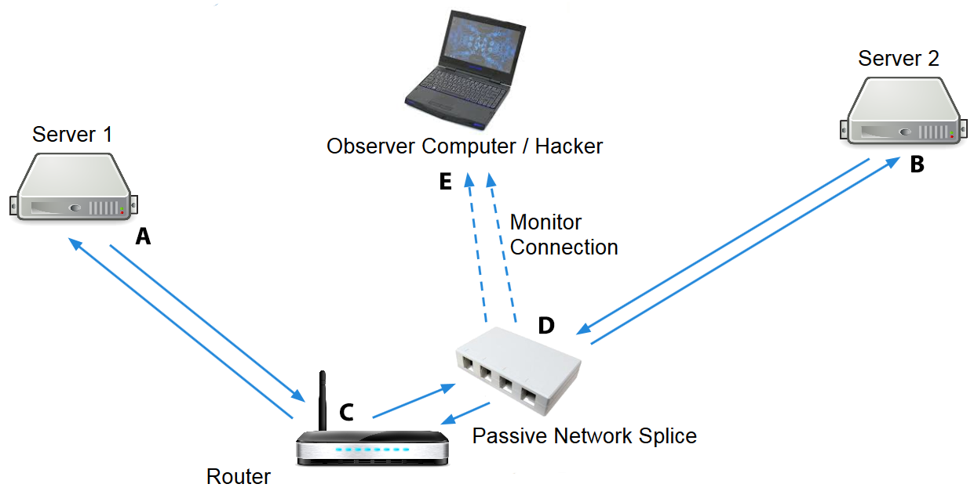
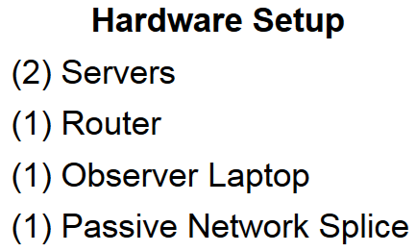
Figure 1. Local Network Configuration
Additionally we decided to test our network implementation on a cloud service provider and chose Microsoft Azure to test our implementation. The software setup on Azure cloud was identical and the servers were deployed in different data centers to ensure our communication was going across separate data centers. The servers were configured with Ubuntu server just like our local implementation and IPsec was installed on the servers. Since our Azure cloud instances live on the cloud there was additional configuration to allow IPsec communication to pass on the network. Ports 50, 51, and 500 had to be opened to allow for IPsec communications. Our West US server was configured with the desktop software to allow us to remote in and run Wireshark. Our network diagram is detailed below
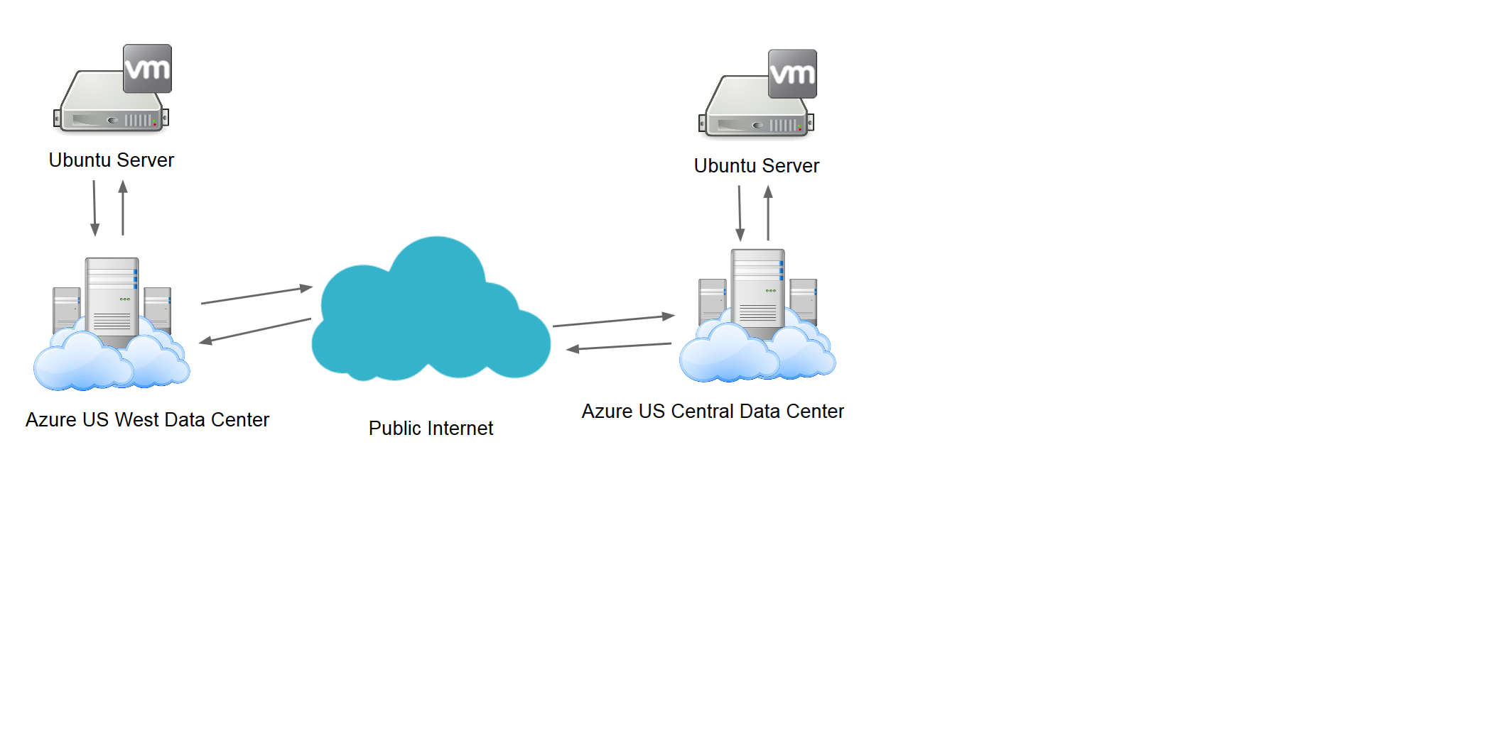
Figure 2. Azure Network Configuration

Router Configuration
Out of the box, our Cisco router was not ready to provide the proper communications facilitation; a few changes needed to occur within the device's settings mechanism. In the router settings accessed via a standard web browser, IPv6 communications routing had to be turned on in place of IPv4.
Although this configuration is relatively simple and would not be scalable to a larger network, its primary purpose is to serve as a demonstration of secure communication between two hosts via IPv6, and other factors (such as address assignment) do not vary greatly from current IPv4 based implementations. With baseline secure communications established in this manner, it would not be difficult to adapt the solution to be more scalable in an enterprise environment.
Once this was taken care of through settings adjustment, the router was adjusted to disable its DHCP IP address-assigning server. This particular setting change allowed us to provide the hosts specific, static IPv6 network addresses in their respective configurations.

IPv6 Configuration
Each host on our network was configured similarly in the networking settings files. The two hosts were setup to have separate, user-defined IP addresses which remained static. These machines were also told what address they could find the router at, otherwise known as the default gateway setting. Finally, network settings were adjusted to remain the same upon reboot, just in case the servers lost power or otherwise needed a reboot power cycle.

IPsec Configuration
IPsec was configured on both of our servers by using a Linux utility called IPsec-tools. This utility allows for a server to be setup to communicate with IP sec with a particular server. This utility should not be used in large implementations, however for a small implementation or a testing scenario, the IPsec tool allows you to setup communication without having to configure an enterprise key sharing solution such as Racoon. Once the tool is installed a configuration file on the server has to be setup to inform the server which host to communicate with using IPsec and what keys to use for the communication. Once these files were setup and the servers completed a reboot power cycle to accept the new configurations, IPsec was successfully configured and encrypting all communication between the two servers.

TESTING
In order to prove our project was performing as expected we had to take on the role of a hacker and sniff the packets being transmitted between our two test hosts. In order to achieve packet sniffing, a hacker would have to physically splice into a network using either a complex device for packet sniffing or create a simple, passive network wiretap. In our case, to not ruin the network cabling, we decided to build a passive wiretap. The point of the wiretap is to create a connection between two network ports, essentially making the ports look like a simple cable. Between these two ports are two network jacks that are spliced on the transmission lines going in both directions. Once a computer is attached to one of these monitoring ports and promiscuous mode is enabled on the network card, the Wireshark network analysis tool will show the frames actively being sent over the network. It is important to note that this tool allowed us to only view one side of the communication at any point in time since we were running a laptop with only one network card. The splitter was configured in such a way that did not allow for the laptop to communicate over the network, only observe the communications on the wire.

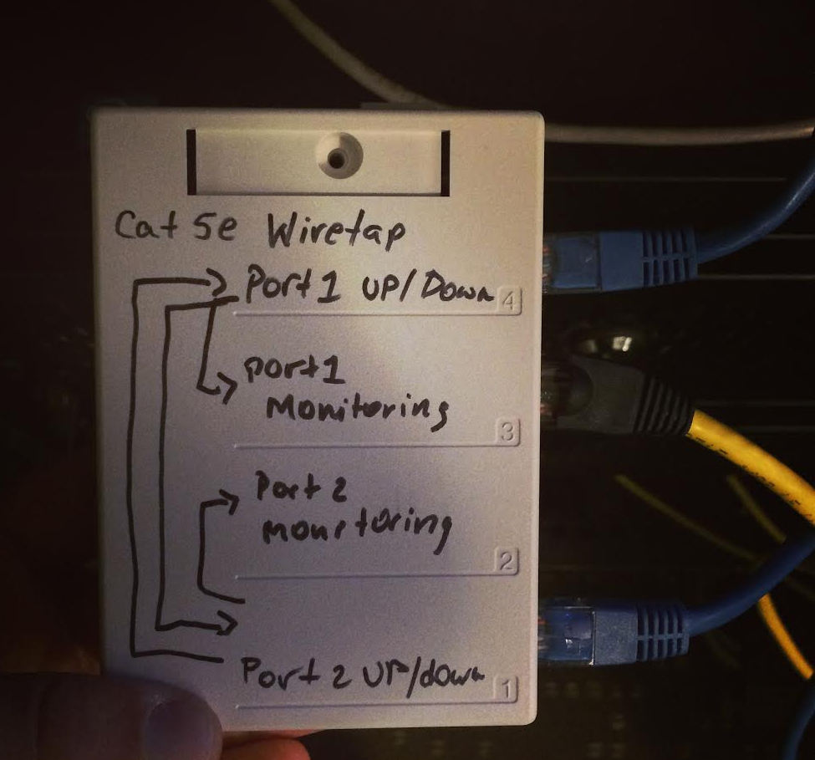
Figure 3. Passive CAT5e Wiretap

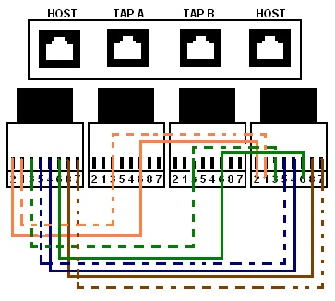
Figure 4. Passive CAT5e Wiretap Internal Diagram

With this device we were able to intercept and analyze the signals being generated by either host in both directions. In order to perform the testing, however, there were a few steps involved. Firstly, all cables attached to the proper ports in our network. This was crucial to observing valid results in the Wireshark application. Next, we disconnected the observation laptop from all networks other than the Ethernet connection to the splice tool, and instructed the Wireshark application to begin listening on the specified network interface. After this was occurring, a command was initiated on each host, independently and sequentially, to send packets in the direction of the other host. After the network packets were sent from each host to the other, network interface sniffing on the laptop was halted, and the process was repeated for the remaining network packet types which were to be tested (HTTP, SSH, and PING).
Testing on our Azure implementation was different since we did not have access to the network cables coming out of our servers in the Microsoft data centers. Wireshark had to be installed on one of our servers to do the network capturing. This eliminated the need of us having a network splice.

RESULTS
The results of the network packet sniffing were a handful of Wireshark network traces. The traces taken on the network contained a small amount of data, which was just enough to properly infer what was occurring. Initial viewing of the trace data provided us with information which indicated that the network hosts were in fact sending IPsec packets using the Encapsulated Security Payloads (ESP) protocol in the payload portion of the frame, rather than standard, unencrypted data.
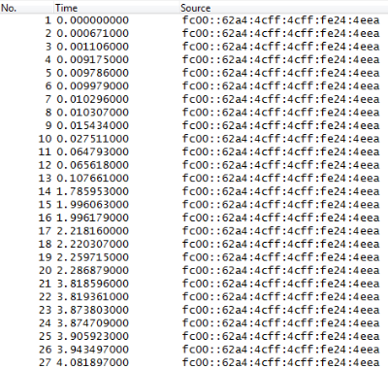
Figure 5. Wireshark Trace Data: Part 1
Shown in Figures 5 and 6, the Wireshark network sniffing program indicates all network data being transferred between the two IPv6 addresses as being of the ESP protocol, instead of representing standard protocols such as ICMP, PING, HTTP, etc. Essentially, this data indicates all network data being transferred between the hosts is encapsulated within the IPsec encrypted network protocol.
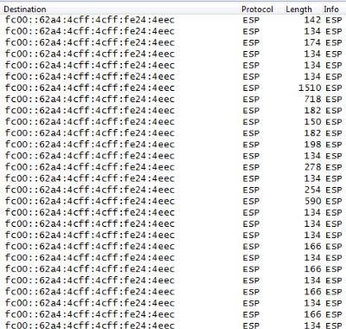
Figure 6. Wireshark Trace Data: Part 2

The results achieved on the Azure cloud were not as successful as the results found on our small test network. Azure was not forwarding our ESP packets over the network but instead filtering our network traffic between the two servers. This was cause for concerns since we had the setup completed on the Azure network just like on our local network. With some further reading of Azure support forums and some support articles that describe how Azure’s network works it is assumed that Azure filters these ESP packets on their network due to Microsoft offering a “Virtual Network” service which can connect two servers to a virtual-type network, even though they are not close to each other. This virtual network option uses VPN technology which implements IPsec for secure communication, or possibly their own proprietary software to encrypt communication between the servers. As a result we found that even though the IPsec implementation has been available for a very long time and works on almost all systems, some large implementation, mainly cloud providers, do not allow you or do not support the creation of your own IPsec setup to securely link your servers to one another.

CONCLUSIONS
With the results available to us at the end of the network testing, we can conclude that it is indeed possible to deploy a secure IPv6-only network with current hardware and software, although there are some significant technical hurdles in doing so. We were also able to determine that even though the current offerings in hardware and software support IPsec over IPv6, some implementations such as Microsoft Azure do not allow you to set this implementation up yourself and require one to obtain a special implementation of their own software / hardware. This is quite disappointing since you cannot setup your own secure network and confirm that all data on this network is being transferred securely. In conclusion, our proof of concept tests are positive, today’s hardware and software support IPv6 and IPsec and works as expected. Our real world tests however came back negative and we found that our implementation does not work in the real world on the Azure cloud and possibly other cloud providers.

BIBLIOGRAPHY
- Cisco. (2014). IP6 IPSec. Retrieved from Cisco: http://www.cisco.com/c/en/us/td/docs/ios-xml/ios/ipv6/configuration/15-2s/ipv6-15-2s-book/ip6-ipsec.html
- Curl. (2014). Manual Curl Usage Explained. Retrieved from Curl: http://curl.haxx.se/docs/manual.html
- Karunaratne, J. (2014). Passive Splice Network Tap. Retrieved from Janitha: http://janitha.com/articles/passive-splice-network-tap/
- nixCraft. (2014). Cyberciti. Retrieved from Ipv6 Apache Configuration Tutorial: http://www.cyberciti.biz/faq/ipv6-apache-configuration-tutorial/
- Ubuntu. (2014). IPsecHowTo. Retrieved from Ubuntu: https://help.ubuntu.com/community/IPsecHowTo

APPENDICES

Gantt chart

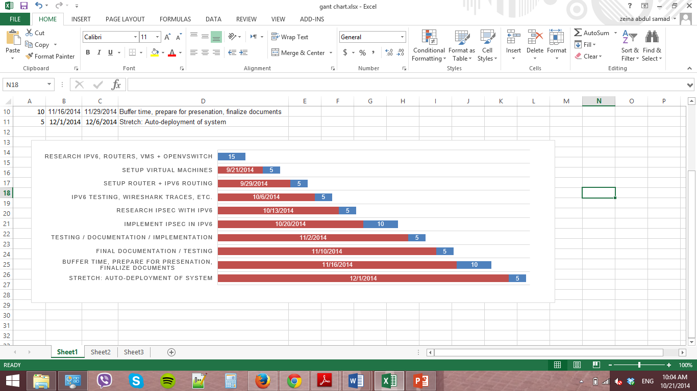
Figure 7. Gantt chart

Tasks Distribution

Date | Task | Assigned People
9/1 - 9/19 | Research IPv6, routers, VMs + OpenvSwitch | All researching the project, IPv6, other technology used for the project
9/21 - 9/26 | Setup Virtual Machines | Doug + Bart + Zeina setup + test VMs. Olivia to research IPv6 router
9/29 - 10/3 | Setup Router + IPv6 Routing | Zeina + Bart to setup router, Olivia + Doug to look into configuration / assist with getting router online and working
10/6 - 10/10 | IPv6 testing, Wireshark traces | All - 2 rounds of Wireshark traces verifying IPv6 connectivity
10/13 - 10/17 | Research IPsec with IPv6 | All - research IPsec cryptography. Will need to meet with professor for guidance/assistance for this portion of the project. Determine whether servers will be physical or virtualized. If virtualized, add required virtualized servers.
10/20 - 10/31 | Implement IPsec in IPv6 | Olivia + Bart - configure IPsec on servers. Zeina + Doug to provide support on IPsec configuration + create documentation of configurations.
11/2 - 11/7 | Testing / Documentation / Implementation | All - test the system for functionality. Evaluate current progress and plan for either stretch goals or for contingency.
11/10 - 11/14 | Final documentation / Testing | Final preparations, write up documentation, evaluate current status of project.
11/16 - 11/29 | Buffer time, prepare for presentation, final documents | Finalize all documentation, all paperwork, create, plan and practice final presentation and verify project architecture meets deliverable requirements.
12/1 – 12/6 | Stretch: Auto-deployment of system | All - Automate the deployment of the systems

